|  |  |
| --- | --- |
| HILADO, Xyleen C. | November 26, 2019 |
| 2-ECE-B | Pandas |

PROBLEM 1

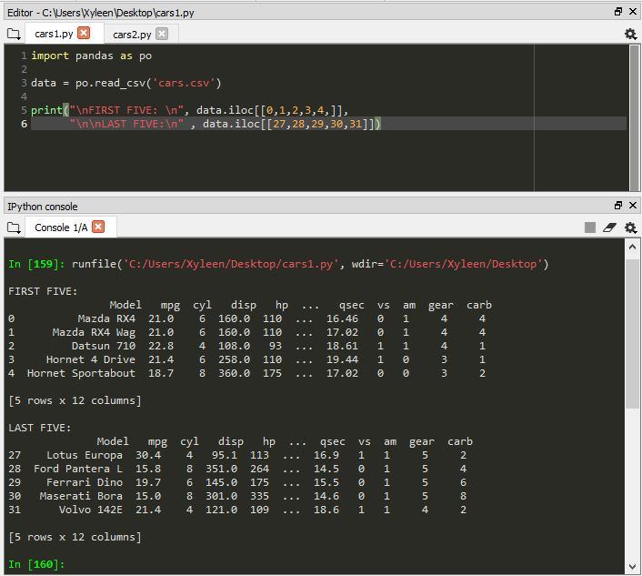

PROBLEM 2